FINAL PROJECT FOR SUMMER TRAINING

Implementations:

#1 Code:

<?xml version="1.0" encoding="utf-8"?> <LinearLayout xmlns:android="http://schemas.android.com/apk/res/android" xmlns:app="http://schemas.android.com/apk/res-auto" xmlns:tools="http://schemas.android.com/tools" android:layout_width="match_parent" android:layout_height="match_parent" android:orientation="vertical" android:padding="16dp" tools:context=".MainActivity"> <EditText android:id="@+id/noteEditText" android:layout_width="match_parent" android:layout_height="wrap_content" android:hint="Enter your note"/> <Button android:layout_width="wrap_content" android:layout_height="wrap_content" android:text="Save Note" android:onClick="saveNote"/> <ListView android:id="@+id/noteListView" android:layout_width="match_parent" android:layout_height="wrap_content"> </ListView> </LinearLayout>

Screenshot:

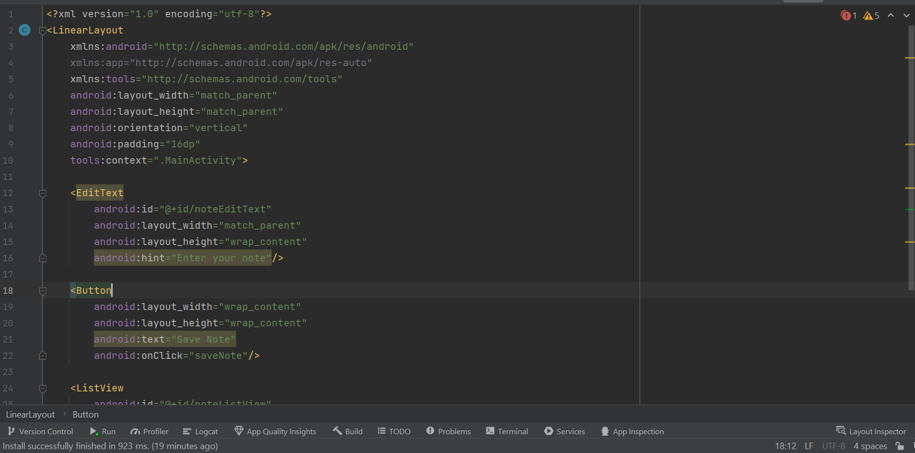

#2 Code:

package com.example.noteit2; import android.os.Bundle; import android.view.View; import android.widget.ArrayAdapter; import android.widget.EditText; import android.widget.ListView; import androidx.appcompat.app.AppCompatActivity; import java.util.ArrayList; public class MainActivity extends AppCompatActivity { private EditText noteEditText; private ListView noteListView; private ArrayList<String> notes; private ArrayAdapter<String> notesAdapter; @Override protected void onCreate(Bundle savedInstanceState) { super.onCreate(savedInstanceState); setContentView(R.layout.activity_main); noteEditText = findViewById(R.id.noteEditText); noteListView = findViewById(R.id.noteListView); notes = new ArrayList<>(); notesAdapter = new ArrayAdapter<>(this, android.R.layout.simple_list_item_1, notes); noteListView.setAdapter(notesAdapter); } public void saveNote(View view) { String note = noteEditText.getText().toString(); if (!note.isEmpty()) { notes.add(note); notesAdapter.notifyDataSetChanged(); noteEditText.setText(""); } } }

Screenshot:

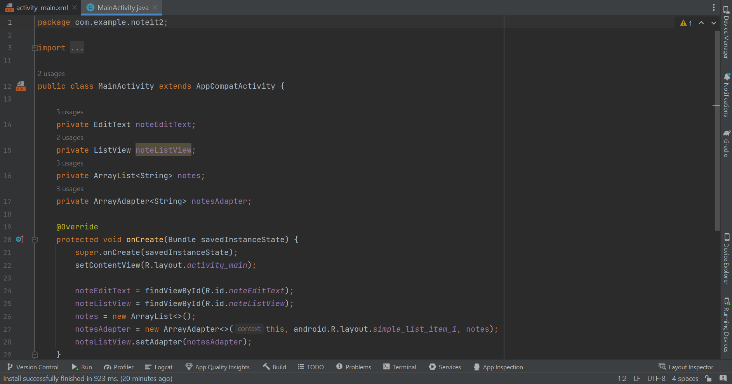

Results:

